# Genetic Maximizer

Table of Contents

Project 3—Problem 2 1

Initial Results: 2

Conclusions: 3

Generations: 3

Population Size: 3

Mutation and Crossover 4

Figure 1 Initial Result 2

[Figure 2 Less Generations 3](https://d.docs.live.net/105ae2b8516a9b24/Desktop/Files/Classes/CS457/Project%203/Project%203%20-%20Results.docx#_Toc72444175)

[Figure 3 More Generations 3](https://d.docs.live.net/105ae2b8516a9b24/Desktop/Files/Classes/CS457/Project%203/Project%203%20-%20Results.docx#_Toc72444176)

[Figure 4 Crossover of 0% 4](https://d.docs.live.net/105ae2b8516a9b24/Desktop/Files/Classes/CS457/Project%203/Project%203%20-%20Results.docx#_Toc72444177)

## Initial Results:

$f\left(x, y\right)=\sin{(π*10*x+10/(1+y^{2}}))+ln⁡(x^{2}+y^{2})$ $\{3 x 10 ∧ 4 y 8∈R\}$:

Maximum: $6.02845680658694$ at $x=9.44606407422541$ and $y=7.97143594484828$

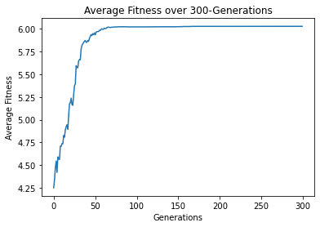

Figure Initial Result

Number of generations: 300

Population size: 100

Mutation Probability: 1%

Crossover: 90%

## Conclusions:

### Generations:

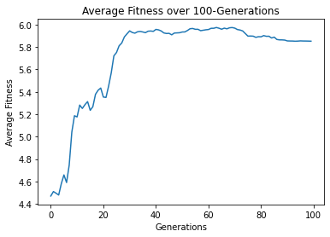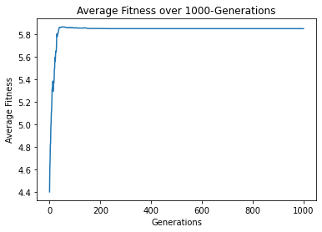From the experiments we did with this algorithm, we realized that the maximum depends on a number of factors. First of all is the generations. Looking at Figure 1, we see that it plateaus after a certain number of generations and either doesn’t improve or improves by very little. If we were to shrink the number of generations down to around 100 generations, we can see in Figure 2 that the result varies and isn’t in a plateaued state. This can lead to less accurate results that are further from the desired result. On the other hand, if there are too many generations, like in Figure 3, while it won’t necessarily do anything bad (most of the time), all it does it waste time and creates a skewed and undetailed graph.

Figure Less Generations

Figure More Generations

### Population Size:

Aside from the number of generations, we have the population size impacting the outcome. In Figure 1, we used a population size of 100. Upon running the algorithm a number of times with the same conditions, the resulting maximum was anywhere between approximately 5.5 and 6. On the other hand, when we increased the population size to 300, we saw that the results were consistently between approximately 5.9 and 6, which is a lot more precise than when we used a smaller population size. Similar to the results from the generations, when using too large of a population size, while it may be more consistent in finding the maximum, the speed at which this occurs is significantly slower than using a smaller population size. So, finding the right balance between population size and runtime is the only major drawback for population size.

### Mutation and Crossover

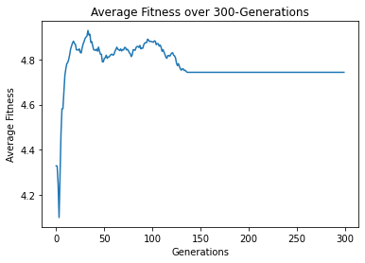The last major easily controllable factors are the mutation and crossover rates. When looking at the final maximum, the mutation rate seemed to have little to no effect, or no noticeable effect on the resulting maximum. While it’s possible that the mutation rate impacts the results more so when there are a smaller number of generations, after enough generations, mutation doesn’t play a major role in the consistency of the resulting maximum. From the data we collected, it is inconclusive as to whether mutation rate actually had a major effect on the result or not.

However, for crossover, it is a different story. With crossover, it creates an opportunity for the values to radically change themselves, instead of mutation, which only affects one digit.

With crossover, setting it to a low value or zero caused the results to be somewhat “luck-based,” meaning that if there weren’t any good starting values, then the result won’t be as good. Looking at the graph in Figure 4, we can see that because the crossover rate was at 0% that the average fitness and subsequent maximum fitness after 300 generations was significantly lower than if we were to have crossover at a higher percentage.

Figure Crossover of 0%

Conversely, with a higher crossover rate, the average fitness is higher after 300 generations, as seen in Figure 1, and the resulting maximum doesn’t depend as heavily on the initial values as with a low crossover rate. In contrast with Population Size and Generations, crossover rate doesn’t seem to have any limiting factors for how high to set the rate. There didn’t seem to be a so-called “sweet spot” for crossover rate, just having a high crossover rate increased the likelihood of the maximum being a more accurate result.